# **Social Tetrahedrons for User Profiles**

# A prototype system for volunteers and learners to engage more fully

## Aim

This memo proposes a “Social Tetrahedron” pilot project for peer learning communities to more easily sense and share what their members value. An initial open source app based on the approach below might be usefully tested in hackathons.

## Baseline concept

Volunteer projects typically experience high levels of burnout and churn. Much of this arises from a lack of sensitivity among participants to one another as whole persons.

A fractal form for member profiles in project teams could help in easing this widespread problem. If successful, a ‘Social Tetrahedron’ app could spark higher levels of attraction and sustained engagement.

Below are draft ideas on how nestable tetrahedral forms might be used to better define and sustain what we value.

**A Tetrahedral Form for Personal, Business and Civic Valuing**

The base triangle forming each person's (or group's) Social Tetrahedron can be defined by three sides, representing basic frames of reference:

* + - Personal (who and what are valued for intrinsic reasons);
    - Business (who and what are valued for purposes of exchange); and
    - Civic (who and what are valued for safeguarding the Commons).

From a top-down perspective, all three frames of the Social Tetrahedron can be viewed at a glance.

The Social Tetrahedron form of each user profile could be transparent in high-trust environments, to reveal its fractal nature. In this way it could show people and initiatives that one includes as part of an extended, empathic self.

This can be done by dragging and dropping other profiles into one's social tetrahedron. By such actions, an individual can populate his or her profile with valued:

* Family and friends (personal frame of reference)
* Colleagues and co-workers (professional or business frame); and
* admired individuals and organizations working for the commons civic frame of reference).

To show that a given person, group, or project is valued simultaneously in multiple frames of reference, the creator of a Social Tetrahedron could do drag and drop insertions via a top-down view, in which all three frames of reference were visible.

This might appear as follows:



*Vertices (with distinct colors) represent non-overlapping value for one’s respective Personal, Business, or Civic valuing frames. Items that are dragged or dropped near the center have synergy with multiple vertices.*

A multiply-valued person, group or project could be positioned close to an ideal point of synergy or balance at the center of the Social Tetrahedron. (By contrast, a person, group or project relevant to only a single frame of reference – e.g. as a generator of Civic value – would appear on that corner of the Social Tetrahedron’s base triangle.)

A further level of insight into the valuing schema of Social Tetrahedrons could be created by offering a "side view" as well as top-down perspective. In this view, a Social Tetrahedron could display as a Maslow-like pyramid with bands of color indicating survival (red), comfort (yellow), or generative (green) conditions in the respective frames of reference. A project, group or person valued under survival conditions – but less so under comfort or generative levels – could be positioned accordingly in a Personal-Business-Civic valuing dimensions.

The following section describes how this Maslow-like system can apply in Spirit-Mind-Body Social Tetrahedrons as well.

**A Tetrahedral Form for Spirit-Mind-Body Valuing**

A second tetrahedral form can be offered to participants that may wish to fill it out. This tetrahedron would complement the first and enable members of a community to more fully appreciate each other as whole persons.

This form would rest on a Spirit-Mind-Body triangle (Heart-Head-Hands), representing the ultimate personal sources of valuing. The vertices in this case stand for respective agendas of spirit, mind, and body. The axial center can be viewed as the ideal attractor for the Soul, with one Soul's path through time orbiting closely or distantly around this central axis. The spiral form can be curved and distended, in response to imbalanced survival and/or reproductive claims by any of the deep valuing vertices – Spirit (lumenes), Mind (memes), or Body (genes) – at the expense of others.

Below is an example of how a Spirit-Mind-Body valuing Tetrahedron can work in a peer learning context:



Aspects of the Spirit-Mind-Body tetrahedron could be made selectively visible to others. The creator of a profile might choose to keep some faces of the Social Tetrahedron opaque, while giving a clear view for others, either fully or partially. Transparency settings for a given face of the tetrahedron might correspond to the access settings.

A user who sought access to opaque or translucent areas could initiate such a request by double-clicking on a surface, and forwarding their request.

**Asks and Offers**

If the creator so desired, outer faces of a Social Tetrahedron also could show opportunities for interaction – including publicly-visible "asks" and "offers" by which anyone can help fill out projects valued by the creator of the Social Tetrahedron. These might appear by hovering over luminous bands on the outside of a member’s (or group’s) profiles. Asks might appear in one color and Offers in another.

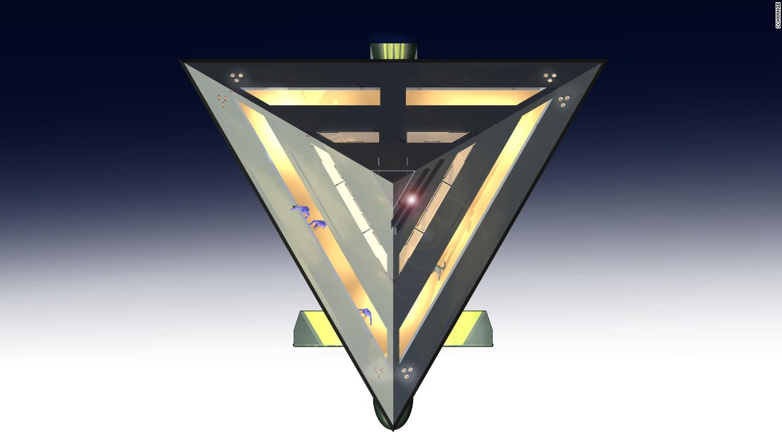

Alternatively, the ask/offer exchange opportunities might be made visible only to people and projects within one's trustnet – specifically, to those already included in one's extended, empathic self.

**Nesting of Tetrahedral profiles**

The Social Tetrahedron framework also provides a means of viewing valued holons. Individuals may choose to nest their Social Tetrahedrons within the Social Tetrahedrons of larger communities, enabling participants to see their identification with a larger connective/collective.

Similarly, the creator of a Social Tetrahedron may opt to show the embedded Social Tetrahedrons of others (individuals and groups) that he or she feels reside within the boundary of their extended/empathic self. Each of these nested Social Tetrahedrons would be as opaque or as transparent as their creators wished them to be. They would retain the right to limit visibility and access to trust networks of their choosing. Or they could give proxy for such access decisions to the creator of the profile in which they were nested.

**Formation of trust relationships**

Over time, mutual "trust tokens" might signify which of these others held delegated rights to act on the profile creator's behalf. Two-way or multi-way delegation of trust in such cases would begin highlighting contours of an incipient larger holon, with its own Personal-Business-Civic (and perhaps Spirit-Mind-Body) frames of reference.

Such relationships might be represented as “valences” that lead to sustained joining of reciprocal ask and offer flows:

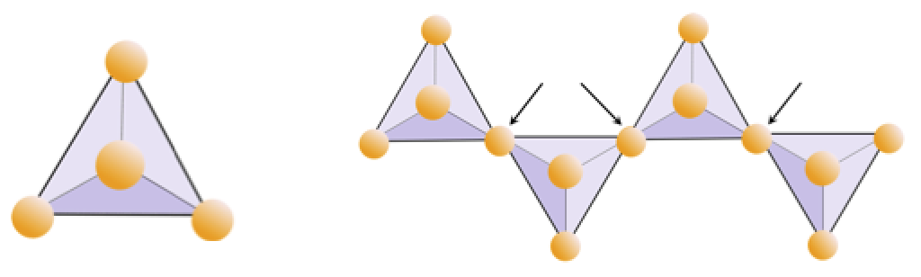

## Possible next steps

1. Review and improve concept
2. Prepare mini-spec for a “minimum lovable prototype”
3. Do inhouse test
4. Define goals and preliminary timeline for a hackathon
5. Identify and invite high potential participants
6. Integrate hackathon improvements into prototype
7. Launch a public beta, with a focus on making the app useful to the global open source hackathan/mathathon community
8. Integrate feedback and new features
9. Identify “stretch goals” for a global crowdfunding campaign for a fully operational Social Tetrahedron rollout

## APPENDIX: Evocative visuals for future UI

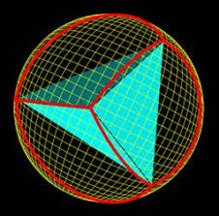

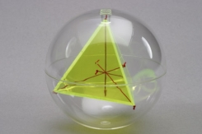

Gnomonic and Stretched Gnomonic Projections of Tetrahedron onto a sphere

(for Asks and Offers, before trust is built)

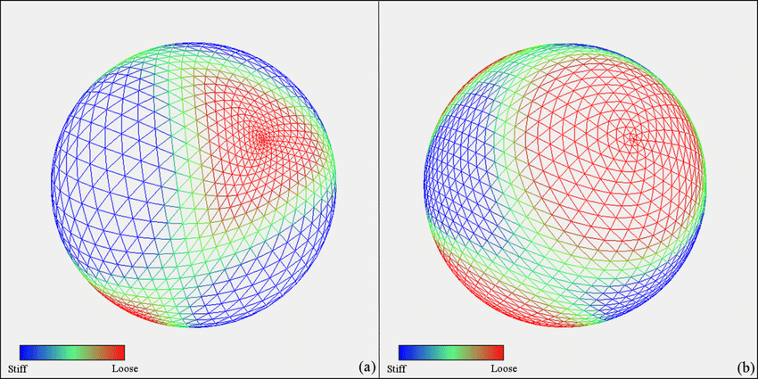

[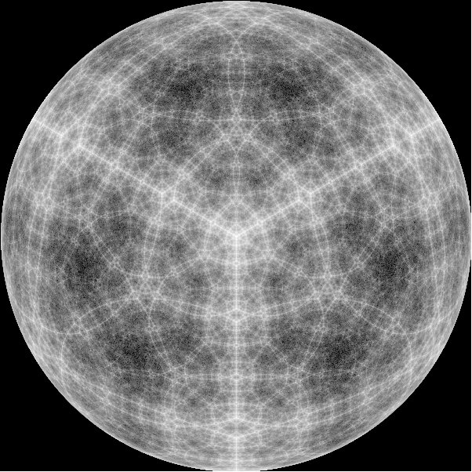](http://bp3.blogger.com/_g8x24bTgTIo/RlJ7wn09_PI/AAAAAAAAADQ/xi6XQ-QcpT8/s1600-h/Quantum+Tetrahedron+-+associated+with+fire.jpg)

Source: <http://vajrasurfers.blogspot.com/2007/05/hedron.html>



Outside view of user profile, with lights signifying asks and offers

**Star tetrahedral form – could depict a person’s joined Personal-Business-Civic**

**and Spirit-Mind-Body valuing frames**



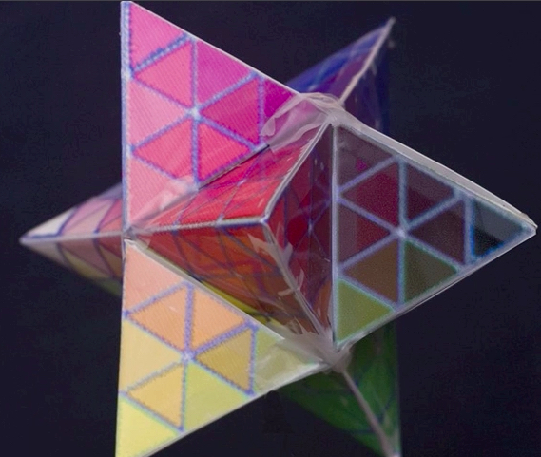

**Cluster of three generative-level Social Tetrahedrons supporting**

**the survival-level needs of another**

